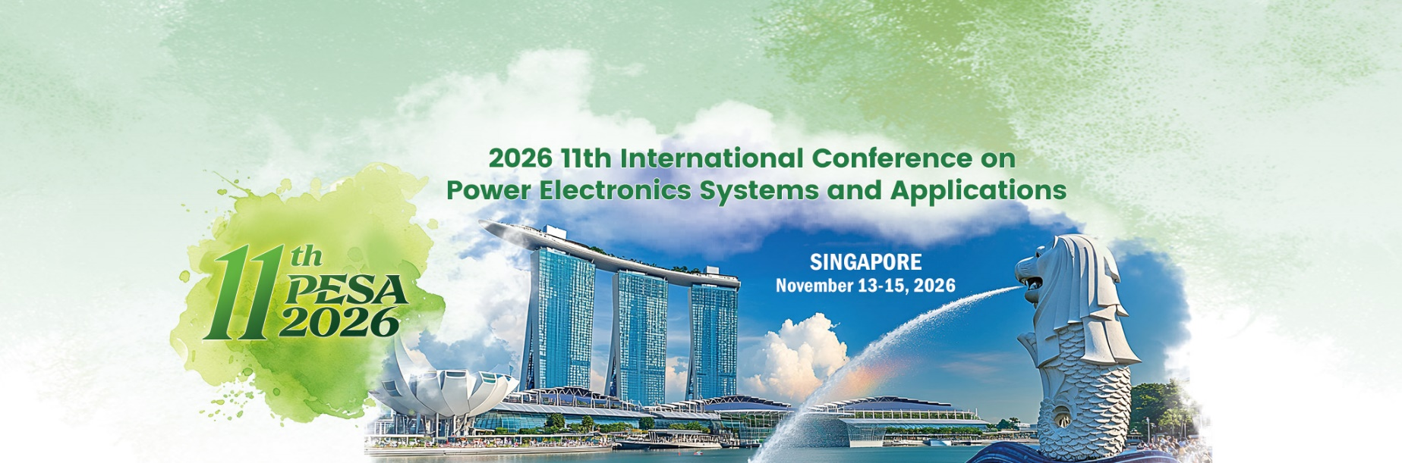

Student Support Program Application
① Name & Affiliation | e.g., Hong Li, Nanyang Technological University, Singapore
② Photo |   Put your photo here
③ Email Address
④ Paper Information | Paper ID  Paper Title:  Author(s):
⑤ Advisor | Name, Affiliation, Personal Page Link
⑥ Brief Statement | Career interests and reasons for attending PESA

Volunteer Recruitment
Volunteer Responsibilities  - Assist with attendee registration and check-in  - Guide participants to sessions and event areas  - Support session chairs with timing and coordination  - Provide basic technical or logistical assistance | Volunteer Benefits  - Gain practical experience in event and conference management  - Build communication and teamwork skills  - Interact with researchers, speakers, and industry professionals  - Receive a certificate
Would you like to be a volunteer for PESA? | □YES □No

**After finish filling the form, please send it to: pesa_secretariat@bmail.org

