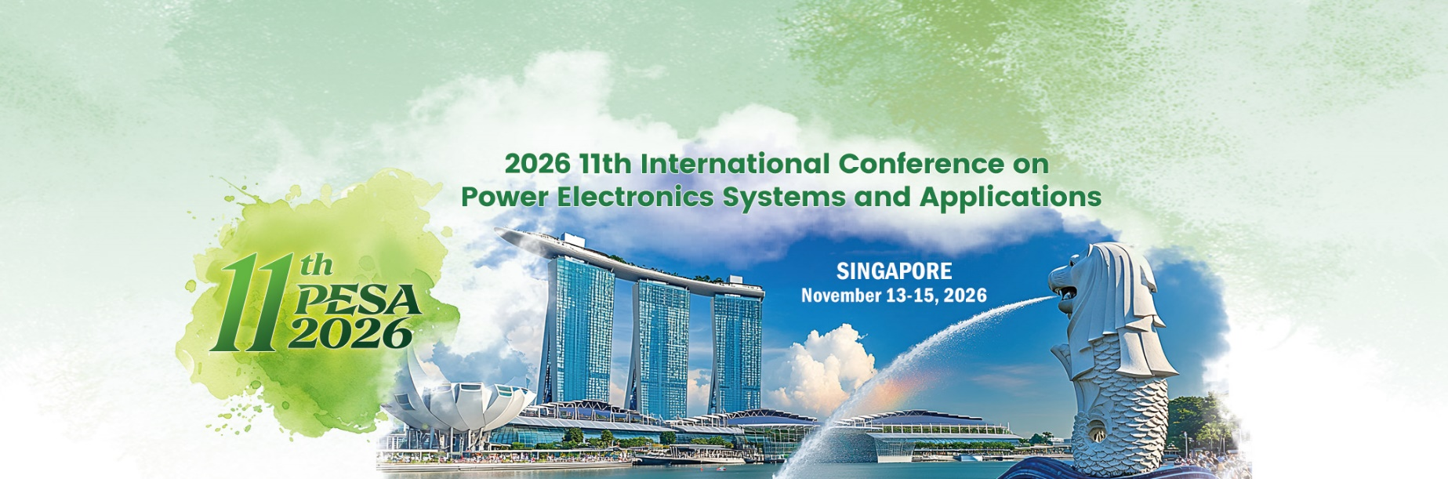

Special Session Proposal

Session Chair Name |  | Photo of session chair
Email |  | Photo of session chair
Cell Phone |  | Photo of session chair
Affiliate & Title |  | Photo of session chair
Co-Chair  Name | If necessary, more co-chair can be added | Photo of co-chair
Email |  | Photo of co-chair
Cell Phone |  | Photo of co-chair
Affiliate & Title |  | Photo of co-chair
Topic of the Special Session
Abstract | Brief description of the Special Session including theme and scope.
Bio (200 words)
Potential Author 1 | Author & nationality
Potential Author 1 | Affiliate & Title
Potential Author 2 | Author & nationality
Potential Author 2 | Affiliate & Title
Potential Author 3 | Author & nationality
Potential Author 3 | Affiliate & Title
Potential Author 4 | Author & nationality
Potential Author 4 | Affiliate & Title
Potential Author 5 | Author & nationality
Potential Author 5 | Affiliate & Title
Potential Author 6 | Author & nationality
Potential Author 6 | Affiliate & Title
**After finish filling the form, please send it to: pesa_secretariat@bmail.org

